Module 2: Baseline Assessment

Session 12: coping Strategies

Handout

What do we mean by ‘coping strategies’?
Coping strategies are the strategies households employ to try and increase their food and cash income after a shock or hazard. Different wealth groups employ different coping strategies, depending on the resources and assets available to them.

Understanding what coping strategies are open to different types of household, and the extent to which these strategies can increase overall food and cash income is important in analysing the overall impact of a shock on households’ access to food and cash. It represents the fifth step in the HEA framework – or the final stage in HEA outcome analysis:

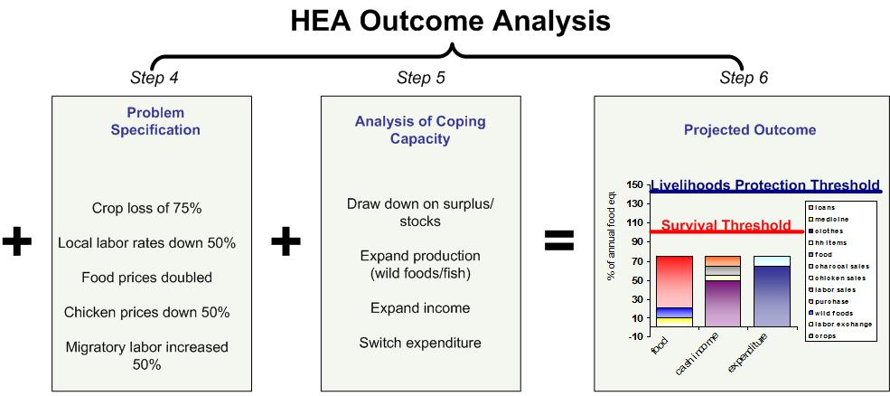
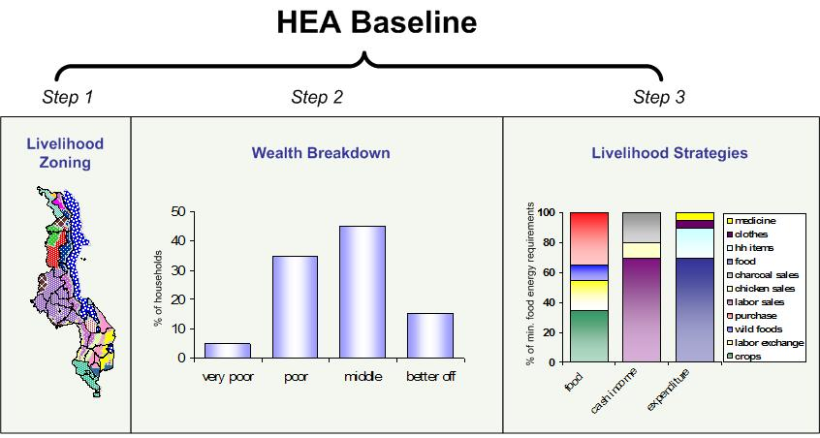

In HEA analysis, this is where households’ coping strategies are taken into account.

Analysis of coping strategies also provides guidance on what to monitor in order to test and revise a predicted outcome. Are people selling more livestock? Are they collecting more wild foods?

HEA explores the range of coping strategies available to different wealth groups in times of food stress. HEA not only lists and quantifies these strategies but also ranks them in the likely sequence they will be employed

Thus, for any particular population group trying to cope with a shock of some kind, the key questions are:
- Which of the existing food and income options can be expanded under current circumstances?
- What additional options can be pursued?
- What effect will these responses have on access to food (i.e. how much extra food can be obtained from these different sources)?

In other words, gathering information on people’s coping strategies is an attempt to provide a quantified picture of households’ ability to diversify and expand access to various sources of food and income, and thus to cope with a specified hazard.

Information on the options open to households when a problem strikes is collected during the baseline study, usually by referring back to previous years and investigating the extent to which particular sources of food or cash could be expanded.

The cost of coping strategies
In HEA, the most important characteristic of a response or coping strategy is its cost, where cost is measured in terms of the effect on livelihood assets, on future production by the household, and on the health and welfare of individual household members. Some strategies can be considered appropriate responses to local stress. In this context, appropriate means both ‘considered a normal response by the local population’ and ‘unlikely to damage local livelihoods in the medium to longer term’.

In many agricultural areas, for example, it may be usual for one or more household members to migrate for labour when times are hard. Provided the response is not pushed too far (i.e. too many people migrating for too long a period of time), this can be considered an appropriate response to stress. Similarly, in a pastoral setting, it is usual to increase livestock sales in a bad year. This again is an appropriate response - provided the increase in sales is not excessive.

But some strategies have undesirable or damaging effects that threaten the sustainability of livelihoods in the medium to longer term. These include selling all productive assets, taking children out of school or entering into prostitution.

Why coping strategies have to be classified in terms of cost
Providing assistance does not always aim solely to prevent outright hunger. It can also aim to preserve assets and to protect livelihoods by helping to minimise the use of damaging response strategies. HEA analysis enables various levels of intervention to be modelled which explicitly either include or exclude particular coping strategies. In other words, it is able to adapt its definition of ‘how far people can cope on their own’ according to the aim of the intervention. If the aim is to support livelihoods as well as to prevent hunger, strategies which are damaging to livelihoods in the medium or longer term will be excluded from the calculations of the level of assistance needed. The analysis will then indicate a level of assistance which will give households the option of not pursuing those high-cost strategies.

Examples of coping strategies and their cost

Stages and types of coping strategies
Sequence of use | Examples
STAGE 1  Low Cost | - Reduced expenditure on non-essential items (beer, cigarettes, ceremonies, festivals, expensive clothing, meat, sugar, more expensive staples, etc.)  - Harvesting of reserve crops (e.g. cassava, enset)
STAGE 2  Medium Cost | - Increased sale/slaughter of livestock (at sustainable levels to maintain herd viability)  - Intensification of local labour activities  - Short-term/seasonal labour migration  - Intensification of self-employment activities (firewood, charcoal, building poles, etc.)  - Increased remittance income  - Increased social support/gifts  - Borrowing of food/cash  - Sale of non-productive assets (jewellery, clothing, etc.)
STAGE 3  High Cost  Excluded from HEA Outcome Analysis. In other words, an intervention would be recommended to keep households from resorting to these. | - Unsustainable sale/slaughter of livestock  - Long-term/permanent migration (including distress migration of whole households)  - Excessive sale of firewood/charcoal (e.g. because of its effect on the environment)  - Sale/mortgaging of productive assets (land, tools, seeds, etc.)  - Prostitution  - Reduced expenditure on productive inputs (fertilizer, livestock drugs etc.)  - Reduced expenditure on health and education  - Reduced expenditure on water  - Decreased food intake

How is information on coping strategies collected in HEA?

Information on coping strategies is collected during interviews with household representatives using Interview Form 4. Information on coping strategies is recorded in the table reproduced below, which is on the last page of the interview form.

Extract on coping strategies from Interview Form 4 (for interviews with household representatives)

THE SITUATION IN A BAD YEAR (INCLUDING COPING STRATEGIES): How does the situation in a bad year compare to the reference year? Consider differences in each source of food and income (quantified changes in amounts) from the reference year and summarize below. Compare quantities from the same period in the reference year and in the bad year (e.g. compare wet season with wet season or dry with dry). Specify which year in the past is being referred to in order to quantify coping strategies.

Source of food or income | QUANTITY in reference year | QUANTITY in bad year
Example: firewood sales | 1 bundle per week | 2 bundles per week
Firewood or charcoal sales
Agricultural labour
Labour migration
Labour exchange (payment in food)
Petty trade
Cattle sales
Shoat sales
Milk and butter sales
Enset consumption
Stocks
Gifts
Other
Other
Other
Other
Other
Other

